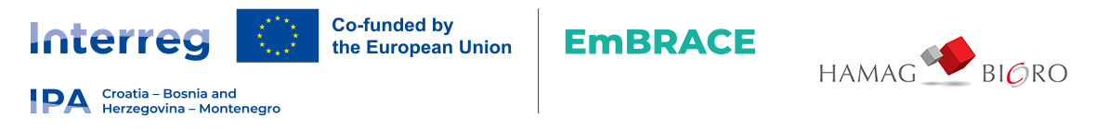

ANNEX IX
Interreg VI-A Programme IPA Croatia-Bosnia and Herzegovina-Montenegro 2021-2027

Declaration on de minimis aid for Final Recipients

Final Recipient - Company name and address
VAT no. / OIB

I, the Undersigned, being the legally authorised representative of the Light Beneficiary organisation, being fully aware that providing false statements in the present declaration constitutes an offence according to the Criminal Code, hereby declare the followings:
- I am aware that the COMMISSION REGULATION (EU) No 2023/2831 of 13 December 2023 on the application of Articles 107 and 108 of the Treaty on the Functioning of the European Union to de minimis aid („De minimis regulation”) allows a „single undertaking” to receive an aggregate maximum amount of de minimis aid of EUR 300,000 per EU Member State under all de minimis aid measure, over any period of three years.
- I am aware that the notion of „single undertaking” involves my organisation together will all enterprises being in a relation to my organisation as defined by Aricle 2 of the De minimis regulation.
- I declare that the organisation I represent together with all other enterprises considered to be a single enterprise with the organisation I represent, received the following de minimis aid to date during the period of 3 years:

De minimis aid granted
Date | Source/Grantor | Name of measure and reference number | Awarded to | Amount in EUR | Member State
Comprehensive amount of de minimis aid granted in Croatia: |  |  |  | EUR
Comprehensive amount of de minimis aid granted in Bosnia and Herzegovina: |  |  |  | EUR
Comprehensive amount of de minimis aid granted in Montenegro: |  |  |  | EUR

Certification

Date
Place
Signature
Name and position

This declaration must, for all Final Recipients individually, be printed and certified by the legally authorised representative of the respective Final Recipient organisation.

